Test Case: tc001_SPX_Dev5_Validar_Filtro_Campo_MenuName_Administrador_Roles_Menu
Step 1 - Enter username and password and click to button Enter : Credentials Entered
Image file-name: QC_Testing-tc001_SPX_Dev5_Validar_Filtro_Campo_MenuName_Administrador_Roles_Menu-abr. 27 2026, 11 24 38 a. m.

Image file-name: QC_Testing-tc001_SPX_Dev5_Validar_Filtro_Campo_MenuName_Administrador_Roles_Menu-abr. 27 2026, 11 24 39 a. m.

Step 2 - Select to UEN and Access to Administrador Roles Menu: UEN Correctly selected and Correct access
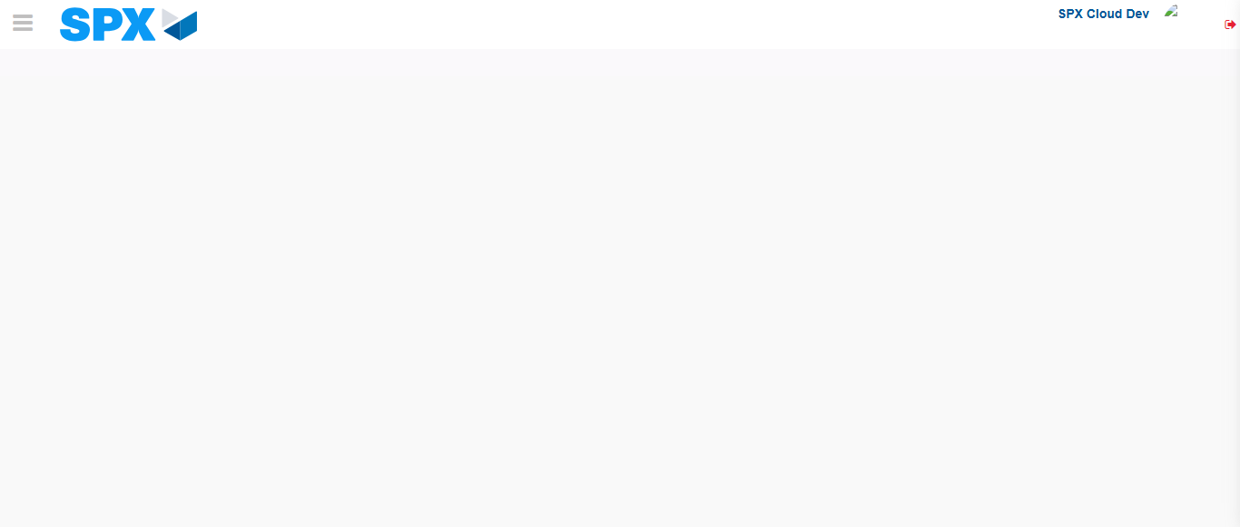Image file-name: QC_Testing-tc001_SPX_Dev5_Validar_Filtro_Campo_MenuName_Administrador_Roles_Menu-abr. 27 2026, 11 24 44 a. m.

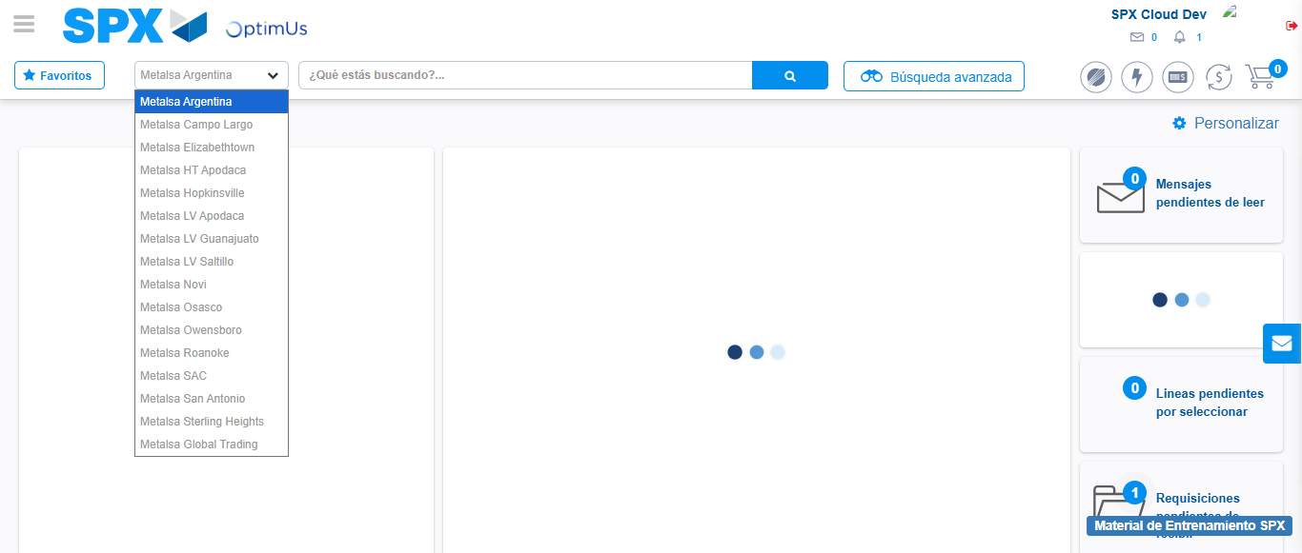Image file-name: QC_Testing-tc001_SPX_Dev5_Validar_Filtro_Campo_MenuName_Administrador_Roles_Menu-abr. 27 2026, 11 24 45 a. m.

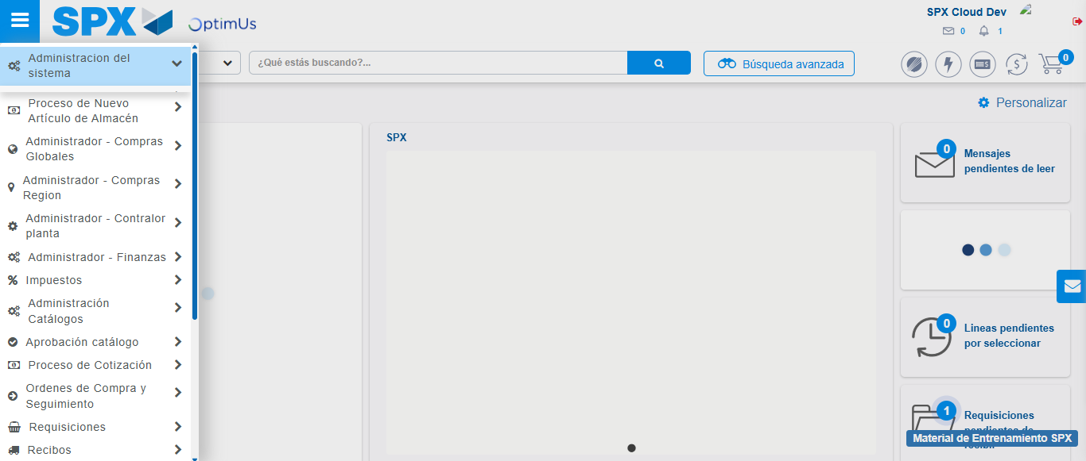Image file-name: QC_Testing-tc001_SPX_Dev5_Validar_Filtro_Campo_MenuName_Administrador_Roles_Menu-abr. 27 2026, 11 24 46 a. m.

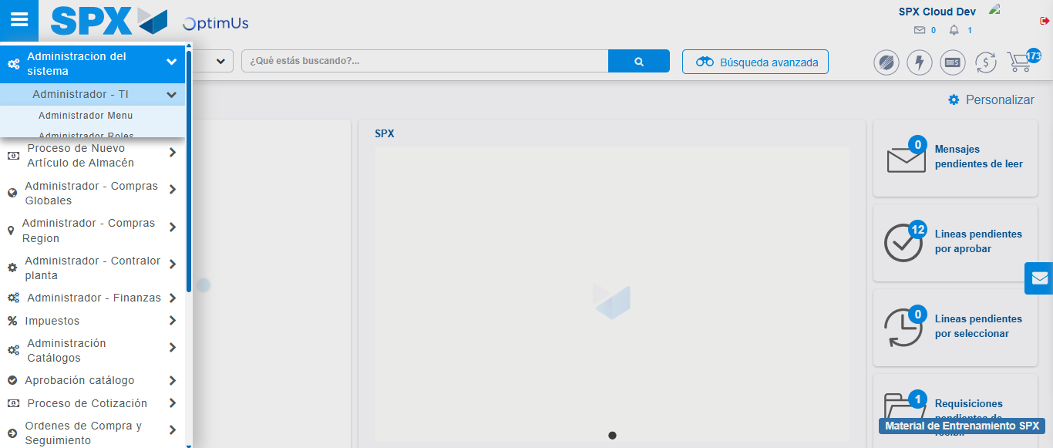Image file-name: QC_Testing-tc001_SPX_Dev5_Validar_Filtro_Campo_MenuName_Administrador_Roles_Menu-abr. 27 2026, 11 24 47 a. m.

Image file-name: QC_Testing-tc001_SPX_Dev5_Validar_Filtro_Campo_MenuName_Administrador_Roles_Menu-abr. 27 2026, 11 25 22 a. m.

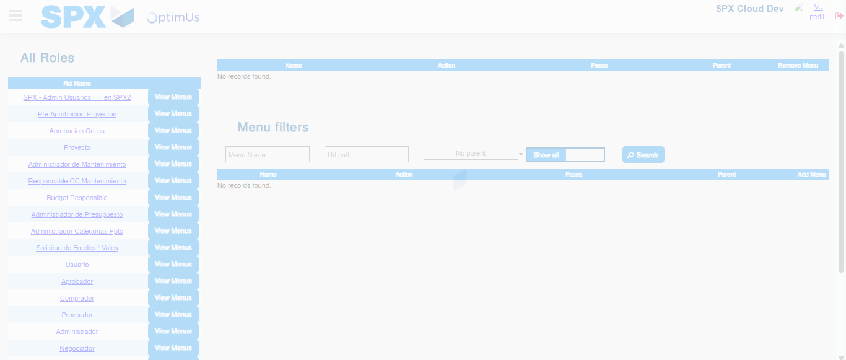Image file-name: QC_Testing-tc001_SPX_Dev5_Validar_Filtro_Campo_MenuName_Administrador_Roles_Menu-abr. 27 2026, 11 25 23 a. m.

Step 3 - Click to Buttons View Menu and Search Filter with Menu Name: Correct Search
Image file-name: QC_Testing-tc001_SPX_Dev5_Validar_Filtro_Campo_MenuName_Administrador_Roles_Menu-abr. 27 2026, 11 25 23 a. m.

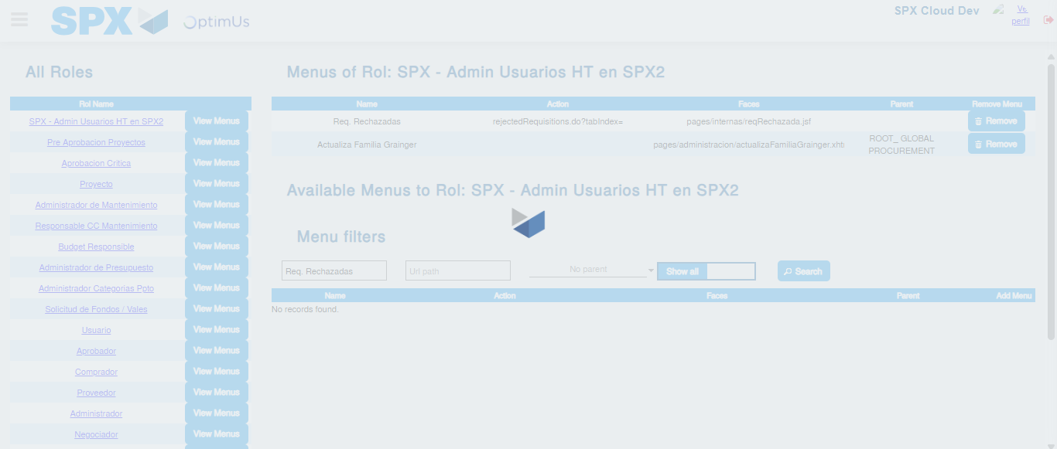Image file-name: QC_Testing-tc001_SPX_Dev5_Validar_Filtro_Campo_MenuName_Administrador_Roles_Menu-abr. 27 2026, 11 25 24 a. m.

